Meta Title
Gnana Saraswati Temple Basar VIP Darshan Booking | Hassle-Free Darshan & Aksharabhyasam

Meta Description
Book Gnana Saraswati Temple Basar darshan for a smooth experience. Avoid long queues, get assisted darshan, Aksharabhyasam booking & pooja support with Vandan Darshan.

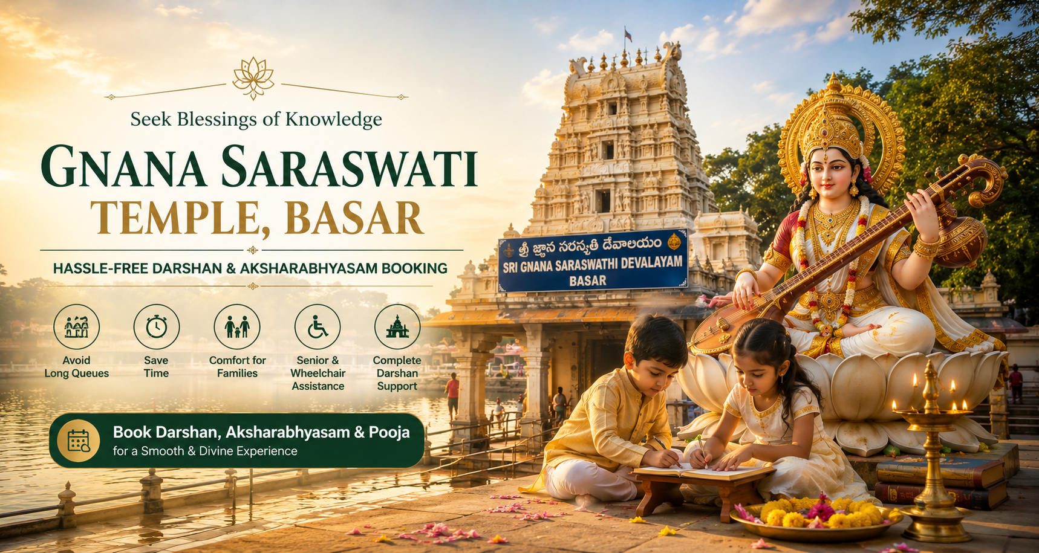

Gnana Saraswati Temple Darshan Booking | Hassle-Free Experience
Darshan at the sacred Gnana Saraswati Temple, Basar, Telangana | Basar, Telangana, India is deeply spiritual but can also be overwhelming due to high footfall, especially during Aksharabhyasam ceremonies, weekends, and festival days like Vasant Panchami.
On normal days, devotees may experience waiting times of 30 minutes to 2 hours, while during peak rush periods, especially school admission seasons and festivals, the crowd can increase significantly, making darshan physically tiring for families, children, and senior citizens.
Visiting a temple of such importance should feel peaceful—but in reality, long queues, confusion around rituals, and crowd pressure can reduce the spiritual experience.
However, your visit does not need to be stressful. With the right guidance and planning, it can become a smooth, meaningful, and well-organized spiritual journey.

🌸 Why Assisted Darshan Matters
This is where assisted darshan support becomes important. Our service helps you experience the temple with comfort and clarity by ensuring:

✔ Avoid Heavy Crowds
We guide you through smoother entry routes and help reduce unnecessary waiting in long queues.

✔ Save Valuable Time
Proper scheduling ensures you complete darshan and rituals without confusion or delays.

✔ Comfortable Family Experience
Special arrangements make the journey easier for children, parents, and elderly devotees.

✔ Wheelchair & Senior Assistance
Dedicated support is available for senior citizens and physically challenged devotees for smooth movement inside temple premises.

✔ Stress-Free Devotion
You can focus fully on Goddess Saraswati’s blessings without worrying about logistics or crowd pressure.

⚡ Faster Darshan Assistance

Limited Slots Available During Peak Days – Advance Planning Recommended

📍 Gnana Saraswati Temple Darshan – Quick Facts
- Location: Basar, Nirmal District, Telangana
- Darshan Timings: 4:00 AM – 8:30 PM (with afternoon break)
- Average Waiting Time: 30 minutes – 2 hours (normal days)
- Peak Rush: Vasant Panchami, weekends, Aksharabhyasam season
- Famous Ritual: Aksharabhyasam (First Writing Ceremony)

❓ Is VIP Darshan Available at Gnana Saraswati Temple?
This is one of the most frequently asked questions by devotees.
There is no official VIP ticket system at Gnana Saraswati Temple.
However, a smoother and faster darshan experience can be achieved through:
- Proper timing selection (early morning / weekday visits)
- Pre-planned Aksharabhyasam or pooja scheduling
- Guided temple assistance services
- Crowd navigation support during peak hours
With the right arrangement, devotees can significantly reduce waiting time and avoid confusion inside the temple premises.

🕰️ Gnana Saraswati Temple Darshan Timings
Ritual / Darshan | Timing | Notes
Temple Opening | 4:00 AM | Daily
Suprabhata Seva | 4:00 AM – 4:30 AM | Morning prayers
Morning Darshan | 4:30 AM – 12:30 PM | General darshan
Aksharabhyasam Ritual | 8:00 AM – 1:00 PM | Based on booking
Afternoon Break | 12:30 PM – 4:00 PM | Temple closed
Evening Darshan | 4:00 PM – 8:30 PM | Resume darshan
Temple Closing | 8:30 PM | Night closure

🌿 What Vandan Darshan Provides

🚖 Easy Pickups
We assist in arranging pickup from nearby locations for a smooth temple journey.

🧭 Smart Crowd Navigation
We guide you through optimal routes to reduce waiting time and avoid congestion.

🎒 Safe Storage Assistance
Help with managing footwear, bags, and belongings securely during darshan.

👵 Senior Citizen Support
Wheelchair assistance and easy access routes for elderly devotees.

🛕 Nearby Temple Planning
Assistance in planning visits to nearby spiritual and cultural locations.

🙏 Complete Darshan Support
From arrival to completion of darshan, we ensure a structured and peaceful experience.

🎓 Aksharabhyasam & Pooja Booking
Participation in rituals at Basar Temple is considered highly auspicious for education and growth.

Available Services:
- Aksharabhyasam Ceremony Booking
- Saraswati Pooja & Archana
- Special Sankalp Rituals
- Prasadam Arrangements

Spiritual Benefits:
- Academic success & focus
- Removal of learning obstacles
- Mental clarity & wisdom

🌸 Poojas Offered at Gnana Saraswati Temple (Vandan Darshan)

🔱 Sankalpa Pooja
Personalized prayer with devotee name, gotra, and intention.

🌺 Archana / Namarchana
Chanting of 108/1000 names of Goddess Saraswati with floral offerings.

🔥 Havan / Homam
Sacred fire ritual for removing negativity and bringing clarity.

🪔 Deep Daan
Offering lamps symbolizing removal of ignorance and darkness.

🌸 Pushpanjali
Offering of sacred flowers and devotion through mantra chanting.

👶 Mundan Ceremony
First hair removal ritual for children seeking divine protection.

📿 Simple Darshan Booking Process
- Select darshan or ritual type
- Choose preferred date & time
- Share devotee details
- Confirm availability
- Receive confirmation & guidance

⚠️ Important Guidelines for Devotees
- Wear traditional and modest attire
- Follow temple discipline and queue systems
- Mobile usage may be restricted inside sanctum
- Reach early during festival or Aksharabhyasam rush
- Carry valid ID if required

⭐ Why Choose Vandan Darshan?
✔ Structured darshan experience
✔ Reduced waiting time
✔ Dedicated ritual assistance
✔ Family-friendly arrangements
✔ Trusted by thousands of devotees

📊 Direct Visit vs Assisted Darshan
Factor | Direct Visit | Assisted Darshan
Waiting Time | High | Reduced
Crowd Navigation | Confusing | Guided
Comfort | Low | High
Planning | Uncertain | Structured
Experience | Stressful | Peaceful

💬 Devotee Experience
“Without proper planning, the temple was extremely crowded. With guided assistance, our Aksharabhyasam and darshan became smooth and memorable.”

❓ Info & FAQs – Gnana Saraswati Temple Darshan

How can I book darshan at Basar Temple?
You can pre-plan your visit and opt for assisted darshan or ritual booking to ensure a smooth experience.

Is VIP darshan available?
No official VIP system exists, but guided assistance helps reduce waiting time significantly.

What is the waiting time for darshan?
- Normal Days: 30 mins – 2 hours
- Peak Days: May be longer
- Assisted Visit: Faster access possible

What is the best time for darshan?
Early morning hours and weekdays are ideal for peaceful darshan.

What is Aksharabhyasam?
It is the sacred ritual where children write their first letters in the presence of Goddess Saraswati.

Can I book Aksharabhyasam in advance?
Yes, advance booking is highly recommended during peak seasons.

Are senior citizens supported?
Yes, wheelchair and assistance support is available.

Is darshan free?
Yes, general darshan is free for all devotees.

Are pooja services available?
Yes, various Saraswati poojas and rituals can be arranged.

Can I visit nearby places after darshan?
Yes, Godavari river ghats and nearby spiritual sites can be included in your plan.

Book Your Gnana Saraswati Temple Darshan Now

